 ***East West University***

**Project Report**

**On**

**A high speed addition method and logic for 4-bit addition**

**Course code:** CSE 360

**Course Title:** Computer Architecture

**Section:** 01

**Submitted To**

Dr. Ahmed Wasif Reza

Assoc. Professor

**Submitted By**

Nasif Wasek Fahim 2017-1-60-037

Priyanka Mondal Piya 2017-1-60-038

Md. Jubayer Hossain Abir 2017-1-60-084

**Date of Submission:** 09 December 2019

**Objective:**To improve speed and reduce delays in the circuit for the 4-bit adder.

**Description:**

**A 4-bit ripple-carry adder:**

A ripple carry adder is simple, which allows for fast design time; however, the ripple-carry adder is relatively slow, since each full adder must wait for the carry-bit to be calculated from the previous full adder.

Delays in a circuit may be caused due to a variety of reasons. The primary shortcoming of a ripple carry adder is the fact that at every bit must wait for the result of the previous carry. This is a significant impediment to circuit speed. Each bit waits for the carry generated at the previous bit, in order to calculate the next sum. This causes delays in the circuit. In contrast, the carry look-ahead adder block calculates the next carry bit with the sum. Due to this, the current bit already has the value of the carry, required to calculate the sum. This significantly improves speed and reduces delays in the circuit.

**A 4-bit carry look-ahead adder:**

Carry look ahead is a digital circuit used for determining the carry bits used by the adder for addition without the wait for the carry propagation. It generates the carry bits for all the stages of the addition at the same time as soon as the input signal (Augend, addend, carry-in) is provided.

The most critical component of this adder is the carry look ahead block. It performs the task of simultaneously calculating the carry so that there need not be any delay in receiving carry from the previous bit. This enables faster computation and the inherent quality of reversible logic based circuits make it a lucrative option for circuit designers.

Cin

C0 = A0B0 + Cin (A0 + B0)

= G0 + P0Cin

C1 = A1B1 + C0(A1 + B1)

= G1 + P1C0

= G1 + P1(G0 + P0Cin)

= G1 + P1 G0 + P1P0Cin

C2 = A2B2 + C1(A2 + B2)

= G2 + P2C1

= G2 + P2(G1 + P1 G0 + P1P0Cin)

= G2 + P2 G1 + P2P1G0 + P2P1P0Cin

C3 = G3 + P3G2 + P3P2G1 + P3P2P1G0 + P3P2P1P0Cin

**Design:**

**A 4-bit ripple carry adder:**

**Block Diagram:**

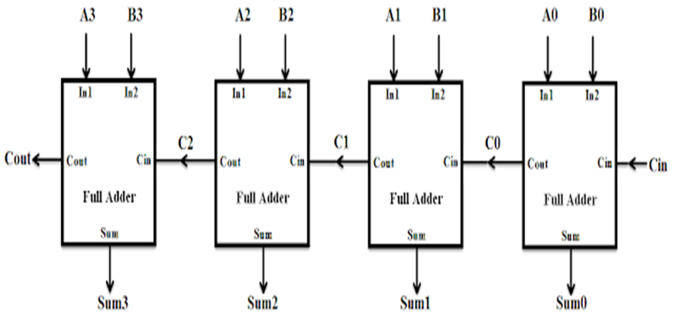

**Circuit Diagram:**

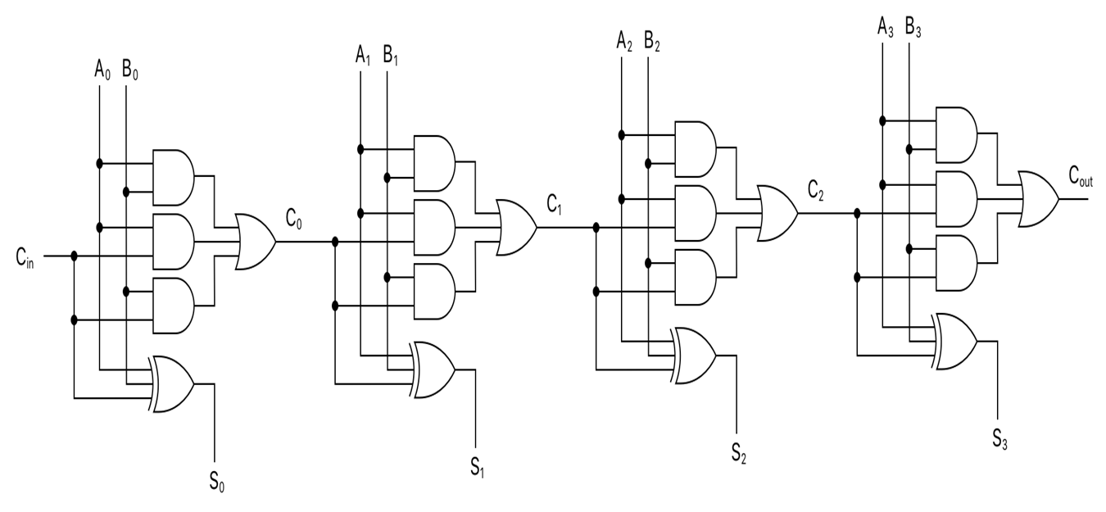

**4-bit carry look-ahead adder:**

**Block diagram:**

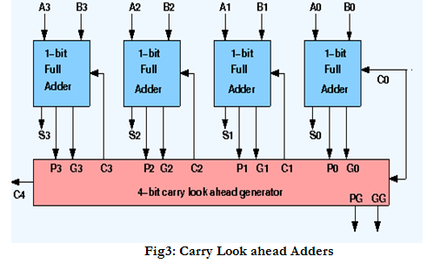

**Circuit Diagram:**



**Implementation:**

**A 4-bit ripple carry adder**

**Verilog Code:**

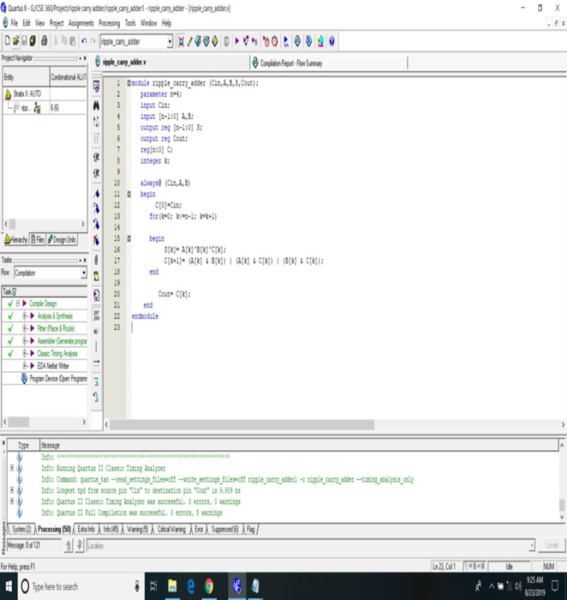

module ripple_carry_adder (Cin,A,B,S,Cout);

parameter n=4;

input Cin;

input [n-1:0] A,B;

output reg [n-1:0] S;

output reg Cout;

reg[n:0] C;

integer k;

always@ (Cin,A,B)

begin

C[0]=Cin;

for(k=0; k<=n-1; k=k+1)

begin

S[k]= A[k]^B[k]^C[k];

C[k+1]= (A[k] & B[k]) | (A[k] & C[k]) | (B[k] & C[k]);

end

Cout= C[k];

end

endmodule

**Compilation Report:**

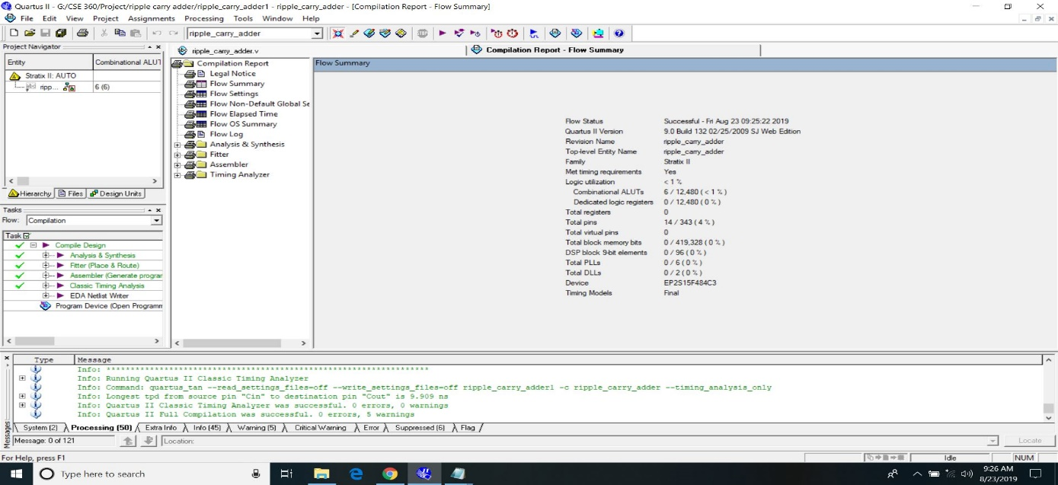

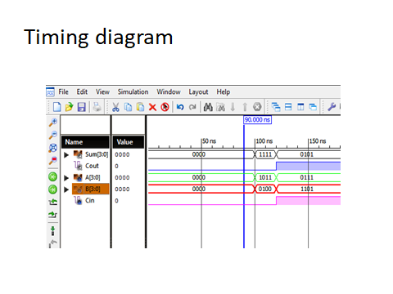

**A 4-bit carry look-ahead adder:**

**Verilog Code:**

module carry_lookahead_adder (Cin,A,B,S,C);

parameter n=4;

input Cin;

input [n-1:0] A,B;

output [n-1:0] S;

output [n-1:0] C;

reg [n-1:0] G;

reg [n-1:0] P;

integer k;

always@ (A,B)

begin

for(k=0; k<=n-1; k=k+1)

begin

G[k]= (A[k]&B[k]);

P[k]= (A[k]^B[k]);

end

end

assign C[0]= G[0] | (P[0] & Cin);

assign C[1]= G[1] | (P[1] & G[0]) | (P[1] & P[0] & Cin);

assign C[2]= G[2] | (P[2] & G[1]) | (P[2] & P[1] & G[0]) | (P[2] & P[1] & P[0] & Cin);

assign C[3]= G[3] | (P[3] & G[2]) | (P[3] & P[2] & G[1]) | (P[3] & P[2] & P[1] & G[0]) | (P[3] & P[2] & P[1] & P[0] & Cin);

assign S[0]= A[0]^B[0]^C[0];

assign S[1]= A[1]^B[1]^C[1];

assign S[2]= A[2]^B[2]^C[2];

assign S[3]= A[3]^B[3]^C[3];

endmodule

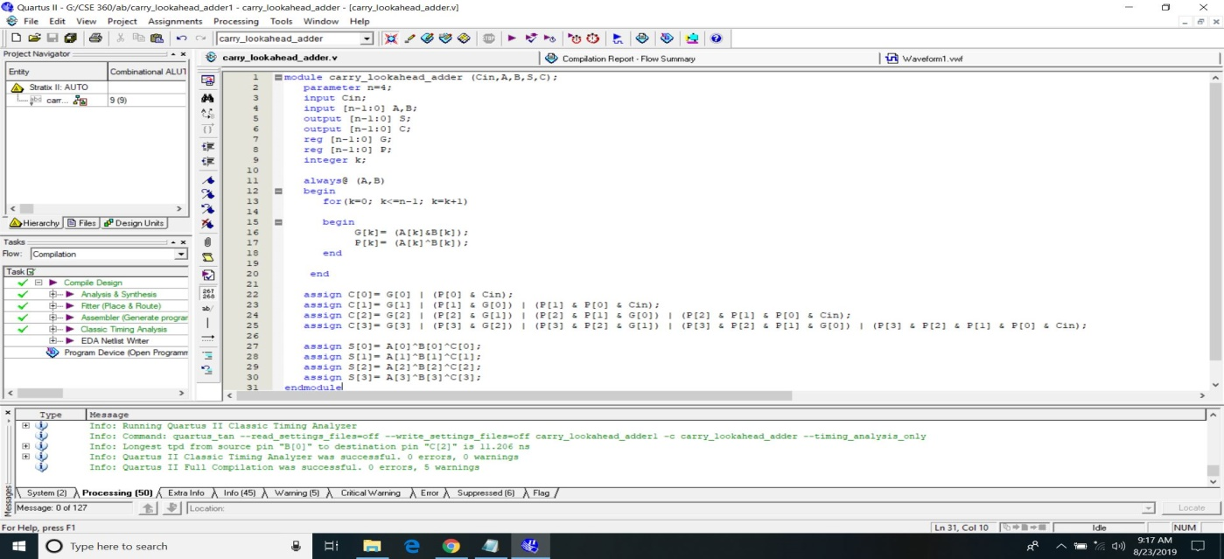

**Compilation Report:**

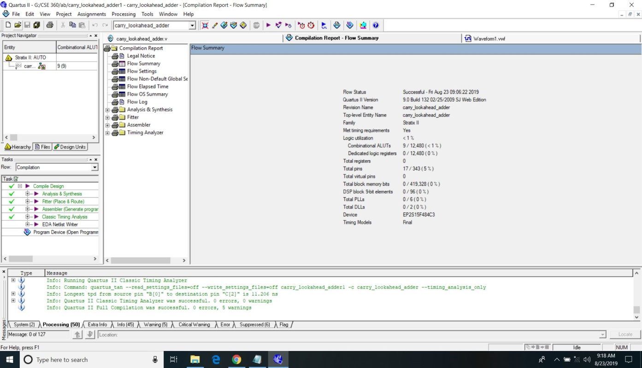

**Results Analysis:**

**A 4-bit ripple carry adder:**

**Timing Diagram:**

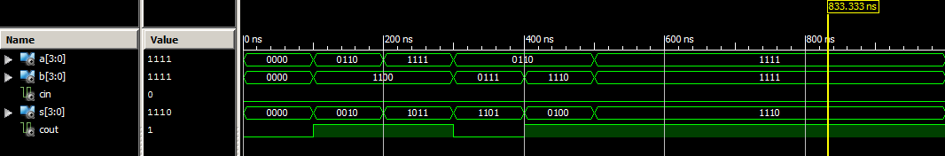

**A 4-bit carry look-ahead adder:**

**Timing Diagram:**

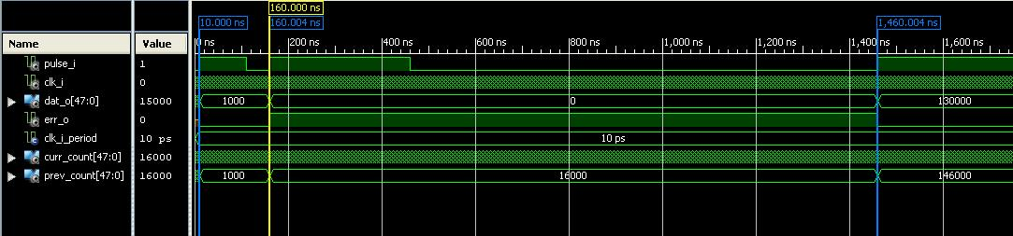

**Advantages:**

* **Carry look-ahead circuit** is a digital circuit.
* **This circuit** significantly improves speed and reduces delays in the circuit.
* **A 4-bit carry look-ahead adder** is **3 percent** faster from **a 4-bit ripple carry adder**.

**Conclusion:**

* As we have discussed in the ripple carry adder that the adder takes a time delay to compute sum because the carry was propagated through all the gates from input to output.
* **To increase the speed of the addition** we need to provide the carry bits used by these adders without the wait for the preceding additions is known as **Carry look-ahead logic**.

**Bibliography:**

1. <https://allaboutfpga.com/4-bit-ripple-carry-adder-vhdl-code/>
2. <https://www.ques10.com/p/17073/explain-carry-look-ahead-adder-and-its-advantage-1/>
3. <https://allaboutfpga.com/4-bit-ripple-carry-adder-vhdl-code/>
4. <file:///C:/Users/HP/Desktop/Different-types-of-adder.pdf>
5. <file:///C:/Users/HP/Desktop/4e70453fb4234608b56d1b952671c829882c.pdf>